Type of the Paper: Peer-reviewed Conference Paper / short Paper
Track title: please fill in your topic title here

Title of the paper
Firstname Lastname ¹, Firstname Lastname ² and Firstname Lastname ^{2,}*
¹ Affiliation 1; e-mail; ORCID (if applicable)
² Affiliation 2; e-mail; ORCID (if applicable)
* Use * to indicate the corresponding author.

Research highlights
Write 2 to 5 bullet points that
1) says in a non-technical language why the readers would be interested in the work,
2) describes the important findings and/or the aim/novelty of the article.
Keywords: keyword 1; keyword 2; keyword 3 (List three to five keywords)
(to be completed by the editors)

Names of the Topic editors:

Names of the reviewers:

Journal: The Evolving Scholar
DOI:

Submitted: 01 January 2021
Accepted:
Published:
Citation:

This work is licensed under a Creative Commons Attribution BY license (CC BY).

© 2022 [Name of the authors] published by TU Delft OPEN on behalf of the authors.

1. Introduction
The introduction section positions the research in a broad context and highlights its relevance to the theme of the chosen track. It explains the aim of the paper and highlights the main conclusions. References should follow APA in-text citation style: use the author’s last name and the year of publication, for example (Wandl, 2019); for direct quotations, include the page number as well, for example (Wandl, 2019, p. 15).
The length of the paper: short paper around 1500 words, with a maximum of 2000 words, excluding the list of references and maximum 3 figures and 2 tables.
Paragraphs follow this format (Figure 1):

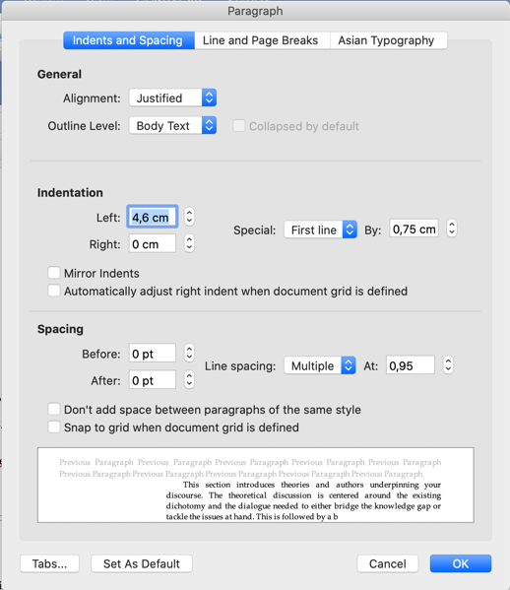
Figure 1. Paragraph format to be used for the body text.

2. Theories and Methods
This section introduces theories underpinning your discourse. The theoretical discussion is centered around the existing dichotomy and the dialogue needed to either bridge the knowledge gap or tackle the issues at hand. This is followed by a brief explanation of the methods used in your research.
In case applicable, research reporting large datasets that are deposited in a publicly available database should specify where the data have been deposited and provide the links.

3. Results
This section elaborates on the research results. It may be divided into subsections.

3.1. Subsection

3.1.1. Subsubsection
You can use bulleted lists:
- First bullet;
- Second bullet;
- Third bullet.
You can also use numbered lists:
- First item;
- Second item;
- Third item.
Below are formats for figures, tables and diagrams.

3.2. Figures, Tables and diagrams
All figures and tables should be cited in the main text as Figure 1, Table 1, etc. The images should be in the format of JPEG (or JPG), PNG or GIF. Please avoid using other formats of images, otherwise, they might not work well in the platform we use (Figure 2). If you are using published images, text or other materials, please be aware of copyright regulations. Detailed information please see the document of instructions for authors, the section on copyright policy.
Figure 2. Describe the figure with a caption. Place the figure in the main text near where it is cited the first time. Diagrams follow the same format.
Table 1. Title of the table. Place the table in the main text near where it is cited the first time. The table can be rotated 90 degree in clockwise direction if more space is needed.
Title 1 | Title 2 | Title 3
entry 1 | data | data
entry 2 | data | data

4. Discussion
This section discusses the research results and how they can be interpreted from the perspective of dichotomies vs. dialogues. Future research directions may also be highlighted.

5. Conclusions
This section summarizes your main conclusions. It is important that you refer to what have been discussed in the previous sections but avoid too many repetitions. Do not include new citations or new ideas in the conclusions.

Data Availability Statement (if applicable)
Provide details regarding where data supporting your research results can be found, including links to publicly archived datasets analyzed or generated during the study.
Contributor statement
Describe properly all author contributions and all types of contribution, see Policies (tudelft.nl)
Acknowledgments (optional)
Acknowledge any other support which cannot be covered by the contributor statement.

References
Use the APA citation system and the APA format, to put the references in alphabetical order (not in the order they appear in the text).
The following examples are from https://www.mendeley.com/guides/apa-citation-guide. Examples are: 1) Book referencing example; 2) Edited book example; 3) Edited book chapter example; 4) E-Book example; 5) E-Book chapter example; 6) Journal Article Example (in print); 7) Journal Article Example (online); 8) Newspaper Articles Example; 9) Magazine Article Example
Please limit the number of references to 15 at maximum.

- Mitchell, J.A., Thomson, M., & Coyne, R.P. (2017). A guide to citation. London, England: My Publisher
- Williams, S.T. (Ed.). (2015). Referencing: A guide to citation rules (3rd ed.). New York, NY: My Publisher
- Troy, B.N. (2015). APA citation rules. In S.T, Williams (Ed.). A guide to citation rules (2nd ed., pp. 50-95). New York, NY: Publishers
- Mitchell, J.A., Thomson, M., & Coyne, R.P. (2017). A guide to citation. Retrieved from https://www.mendeley.com/reference-management/reference-manager
- Troy, B.N. (2015). APA citation rules. In S.T, Williams (Ed.). A guide to citation rules (2nd ed., pp. 50-95). Retrieved from https://www.mendeley.com/reference-management/reference-manager
- Mitchell, J.A. (2017). Citation: Why is it so important. Mendeley Journal, 67(2), 81-95
- Mitchell, J.A. (2017). Citation: Why is it so important. Mendeley Journal, 67(2), 81-95. Retrieved from https://www.mendeley.com/reference-management/reference-manager
- Mitchell, J.A. (2017). Changes to citation formats shake the research world. The Mendeley Telegraph, Research News, pp.9. Retrieved from https://www.mendeley.com/reference-management/reference-manager
- Mitchell, J.A. (2017). How citation changed the research world. The Mendeley, pp. 26-28

