ARCH22 ‘Enabling health, care and well-being through design research'
5th Architecture Research Care and Health conference, Delft / Rotterdam – 22 - 24 August 2022.
NOTE: Please be aware that these instructions might be updated. Check the latest version online at the conference website https://arch22erasmusmc.tudelft.nl/
The Evolving Scholar Publishing process
The Evolving Scholar (ThES) is a community-driven open-access journal published by TU Delft OPEN. Only accepted abstract will be invited to submit to The Evolving Scholar, a full conference paper or a short conference paper.
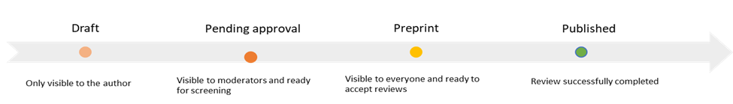
Figure 1. the publication process.
Instructions for authors
- Manuscript preparation
- Make use of our templates to submit your full conference paper or a short conference paper.
- Research Data- Authors are strongly encouraged to register their dataset in a recognised research data repository- please visit this page for more information.
- Open Access Policy
The Evolving Scholar is licensed under one of the following Creative Commons licenses:
  - CC BY 4.0 license. The license means that anyone is free to share (to copy, distribute, and transmit the work), to remix (to adapt the work), however, under the conditions of giving appropriate credit, providing a link to the license, and indicating if changes were made.
  - CC BY-ND 4.0 license. This license lets others reuse the work for any purpose, including commercially; however, it cannot be shared with others in adapted form, and credit must be provided to you.
You will be asked to choose a license during the submission process
- Copyright Policy
  - Authors retain their copyrights.
  - if you are using published images, text or other materials, please be aware of copyright regulations. The TU Delft Copyright helpdesk can provide further information and answer your copyright questions.
  - In case of (alleged or proven) copyright breaches or scientific misconduct (e.g. fabricating data), The Evolving Scholar will follow the guide developed by the Committee on Publication Ethics (COPE)
- Plagiarism
  - All submissions will undergo a similarity check, the results of which will be shared with the scientific community. In case of suspected plagiarism, the authors will have 2 weeks to provide an explanation.
  - Reproducing a part of a published content or images is allowed if the original source and authors are respectively referred to and are given proper credit.

- Submission
- Signup in the platform
  - Go to the platform website
  - Click on “Log in / Register” button. It is recommended to log in using an ORCID ID (personal or via your institutional account). If you don’t have an ORCID ID, or you are not sure of the benefits of using it, please check this website to obtain your free ORCID ID. If you need some help about how to log in in the platform, please check this guide.
  - Once you logged in, click on the notification icon on the toolbar and follow the basic onboarding process. Please check this guide if you need some help.
  - You are now ready to submit your paper.
- Paper submission
  - Go to the ARCH22 community page
  - Click on “Join the community” button.
  - Click on “Upload” button.
  - Enter the title of your paper and follow this guide if you need help about how to edit and submit your conference paper*.
- Any issues with the submission process please check the guides, use the feedback button, or contact publishing-lib@tudelft.nl

- Review process
See figure 1 for the publication process.

Your conference paper will be openly peer-reviewed. It means Authors and Reviewers/Editors are aware of each other’s identity, communicate transparently throughout the entire process.

